Activity No 2.Finance Club Event “The Balanced Budget”

Title of the Event | Finance Club Event “The Balanced Budget” | 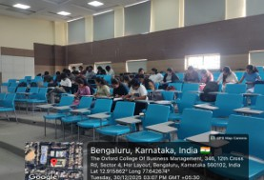
Day and Date | 30.12.25
Venue (With all details ) | Roon No-407
In collaboration with ( if any) | -
Details of Resource Person With Designation | Asst.Prof. Ritu U | 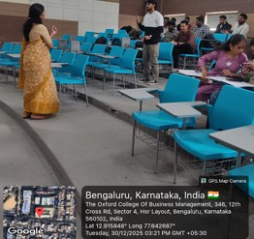
Organizing Department/Coordinators | Business Management . Asst.Prof. Ritu U
Course and semester | MBA I Semester
No of Students & Faculty Participants | 28

Coordinator HoD Vice-Principal Principal

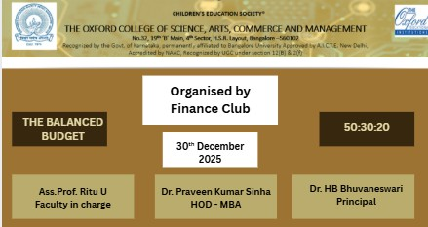

Introduction
On December 26, 2026, the Finance Club held an educational workshop from 3:00 PM to 3:30 PM centered on the 50/30/20 budgeting framework. This session aimed to provide students with a simplified, actionable strategy for managing their future income. By breaking down complex personal finance into three distinct categories, the presentation helped demystify how to balance immediate needs with long-term financial health.

Description of the Activity
The core of the session focused on the first and largest category: 50% for Needs. Students learned to identify essential expenses—such as housing, groceries, utilities, and transportation—that are non-negotiable for survival.The second half of the workshop explored the remaining 50% of the budget, split between 30% for Wants and 20% for Savings and Debt Repayment.

Outcome of the Activity
Students engaged in a lively debate over the "Want vs. Need" distinction, such as a basic phone plan versus the latest smartphone upgrade. We emphasized that the 20% allocated to savings is not just "extra money" but a "payment to your future self," intended for emergency funds, retirement, or investing.

Conclusion
The session concluded with a practical demonstration of how this ratio provides flexibility across different income levels. By the end of the 30-minute meeting, participants understood that budgeting isn't about restriction, but about intentional spending. Students left the club with a clear template to help them prioritize their financial goals and avoid the common pitfall of "lifestyle creep" as their future earnings grow.

